# Editing Files in LINUX

## Scenario

You walk in Monday morning and hear some interesting gossip as you pass the lunchroom. Mr. X has been let go and has a replacement, Mrs. Y. As you approach your desk, you see an extremely professional, younger lady you presume to be Mrs. Y. In her hands is a giant stack of printouts from the most recent audit log that you created for sharing. It seems as though the **SharedFolder** was a direct connection to an internal affairs office. She has noted that you are in the clear for any wrong doing, but any previous agreements with Mr. X are null and void. In doing so, her only task for you for this week is to ensure that you are able to edit files using the commonly used applications VIM and nano.

## Objectives

In this lab, you will:

* Use the **vimtutor** executable to conduct lesson 1 through lesson 4
* Copy content from the **/tmp/log/secure** file, and edit with nano

## Exercise 1: Run the vim Tutorial

As Mrs. Y walks away, she mentions that the vimtutor application is highly recommended as it provides a solid foundation of practice to get through the vim basics. As such, your first task is to get through the first four lessons of the vimtutor program.

Helpful Hints

* You may have to use **sudo** to conduct this if you are not root.
* If vimtutor does not work, you may need to install vim using **sudo yum install vim**.

### TODO

1. From the terminal, run **./vimtutor** and follow all directions in the file for lessons 1 through 4. Takes approximately 30 minutes to complete.

### Steps

1. From your current location, type **vimtutor** and press ENTER to enter the vimtutor session.
2. Conduct steps 1 through 4.
3. Type **:q!** and press ENTER to exit the vimtutor.

## Exercise 2: Edit a File in nano

One of the other alternative command-line editor programs is nano. Use nano to edit a copy of a log file **/tmp/log/secure**. Replace all usernames with the default **#####**

Helpful Hint

You may have to use **sudo** to complete this exercise if you are not root.

### TODO

1. Copy **/tmp/log/secure** to **~/companyA/securecopy.txt**.
2. Use nano to edit the file, removing any usernames and replacing them with 5 “**#**” symbols, regardless of the size of the original username.

### Steps

1. Validate that you are in the **/home/YOURUSERNAME/companyA** folder by typing **pwd** and pressing ENTER.
2. Copy the contents of the **/tmp/log/secure** file to the **companyA** folder by typing **sudo cp /tmp/log/secure securecopy.txt** and pressing ENTER.
3. Using the nano text editor, edit the **securecopy.txt** file by typing sudo **nano securecopy.txt** and pressing ENTER.
4. To search and replace for the username **root**, press **ALT-R** and press ENTER. Type root in the **Search (to replace)**: box and press ENTER.
5. In the **Replace with**: box, type **#####** and press ENTER.
6. At the **Replace this instance?** prompt, type **A** and press ENTER to replace all instances of the word root with **#####**.

Ex: Find and replace

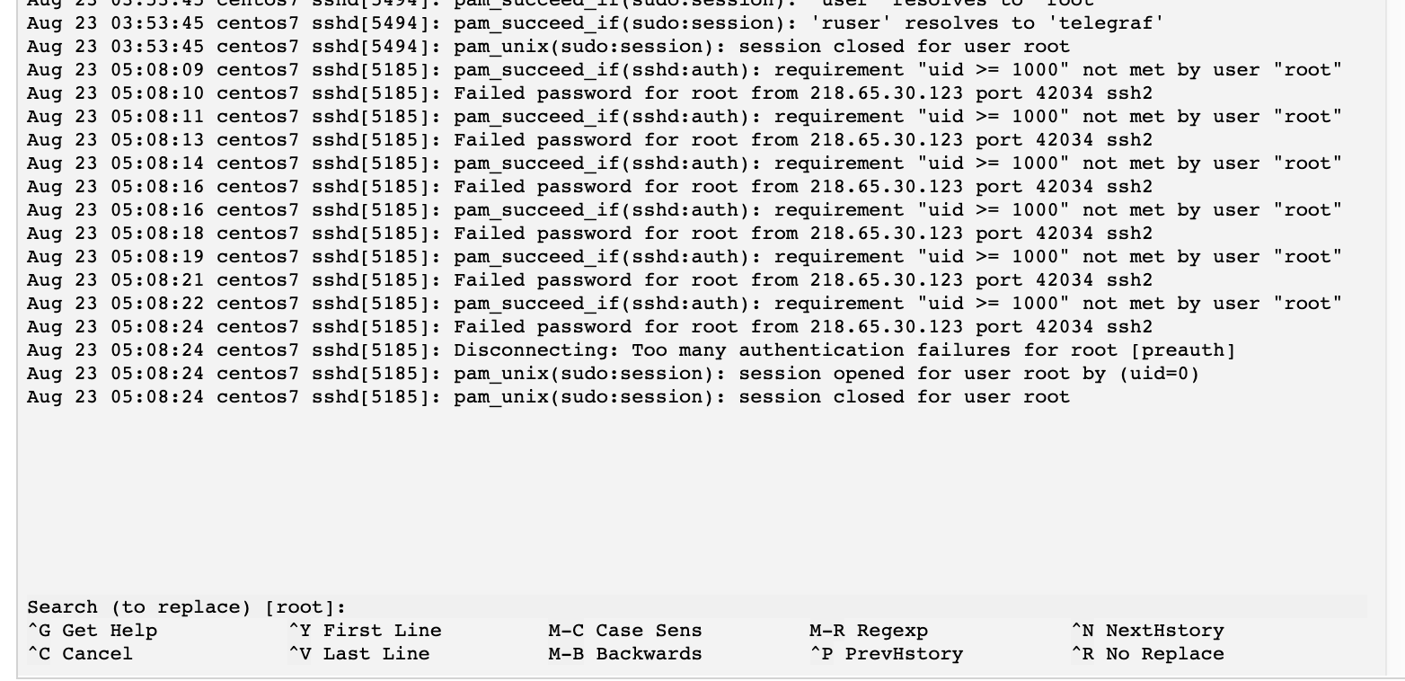

Ex: All users root replaced

